1. **CodeDeploy Overview:**

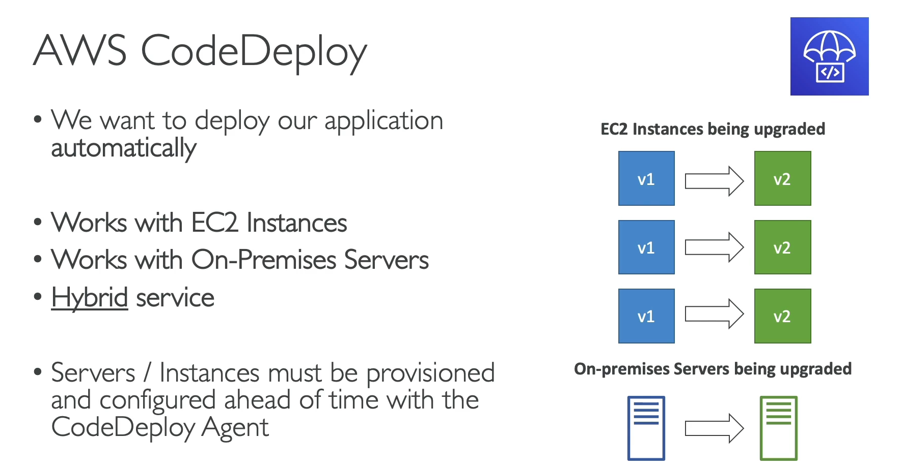

**CodeDeploy** is an AWS service that automates the deployment of application code to a variety of compute services, including **Amazon EC2 instances**, **on-premises servers**, and other services like AWS Lambda and Amazon ECS. It is a standalone service that doesn't require you to use CloudFormation or Elastic Beanstalk.

**Key Principles and Benefits**

* **Hybrid Service**: A key feature of CodeDeploy is its ability to function as a **hybrid service**, meaning it works with both **on-premises servers** and **Amazon EC2 instances**. This is especially useful for companies in the process of migrating to the cloud, allowing them to use a single deployment tool for all their servers.
* **Application Deployment Automation**: CodeDeploy automates the process of rolling out new versions of your application. You can deploy from any source (e.g., S3, GitHub, Bitbucket), and CodeDeploy will manage the transition from a previous version to a new one.
* **Prerequisites**: Unlike Beanstalk, which provisions the servers for you, CodeDeploy requires you to provision your servers (EC2 or on-premises) **ahead of time**. To enable deployments, you must manually install the **CodeDeploy agent** on each server you want to manage.
* **Flexible Deployment Strategies**: CodeDeploy supports different deployment strategies, such as:
  + **In-place deployment**: The new version of the application is installed on the same set of instances, one at a time.
  + **Blue/Green deployment**: A new set of instances is created with the new application version, and traffic is shifted to them after a successful deployment, allowing for easy rollback if needed.
* **Independent from Other Services**: CodeDeploy is independent and does not require you to use other AWS services like CloudFormation or Beanstalk. This makes it a flexible tool for automating deployments to a variety of environments.

1. **CodeCommit Discontinuation:**

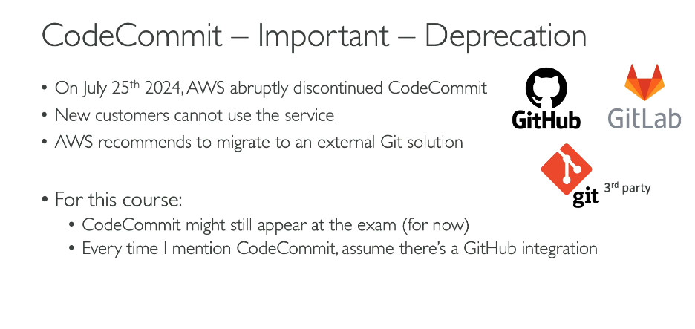

You are correct. As of July 25, 2024, AWS CodeCommit is no longer available to new customers. AWS has officially recommended that new and existing customers migrate to a third-party Git solution, with services like GitHub, GitLab, and Bitbucket being common alternatives.

**Key Takeaways**

* **Service Discontinuation:** AWS CodeCommit is no longer accepting new customers as of July 25, 2024.
* **Migration Recommended:** AWS is actively encouraging existing users to migrate their repositories to another Git hosting service.
* **Exam Relevance:** Despite the change, CodeCommit may still appear on some legacy exams. The key concept to understand is that it functioned as a **fully managed Git repository service**.
* **GitHub as a Replacement:** For the purpose of the course and understanding the broader AWS ecosystem, you should think of CodeCommit as being functionally equivalent to **GitHub**. Where the course mentions CodeCommit, assume it is talking about a standard Git repository service (like GitHub) that can be integrated with other AWS services.
* **Analogy:** Just as Amazon S3 is a storage solution and Amazon RDS is a database solution, CodeCommit was AWS's solution for Git-based source control. However, AWS is now shifting its strategy to focus on integration with best-of-breed third-party services for this function.

1. **CodeCommit Overview:**

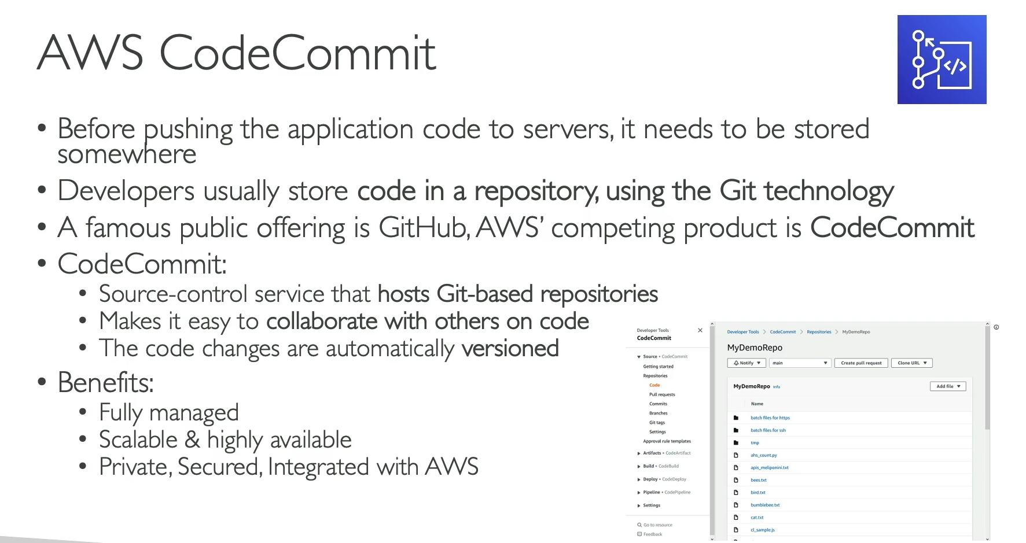

**AWS CodeCommit (Git Repository Service)**

* **Purpose:** CodeCommit was a managed service that served as a private, version-controlled code repository for developers. It was designed to store and manage source code using **Git technology**.
* **Core Functionality:**
  + **Git-based:** It provided a standard Git-based repository, making it easy for developers to collaborate, version code changes, and roll back to previous versions.
  + **Fully Managed:** AWS handled the underlying infrastructure, including provisioning, scaling, and maintenance. This allowed developers to focus on writing code instead of managing their own Git server.
* **Key Benefits (as described in the text):**
  + **Private and Secure:** As an in-account service, CodeCommit provided a private and secure repository, with tight integration to AWS Identity and Access Management (IAM) for granular access control.
  + **Highly Available and Scalable:** Leveraging AWS's infrastructure, it was designed to be highly available and to scale automatically to handle large repositories and a high number of requests.
  + **Integration with AWS Services:** One of its main advantages was its seamless integration with other AWS services, particularly the **AWS Developer Tools**, to build complete CI/CD pipelines.

**Important Context from Previous Lectures**

As you have previously been informed, AWS announced the discontinuation of CodeCommit for new customers as of July 25, 2024. While the service still exists for existing users, AWS is recommending that all customers migrate to a third-party Git solution, such as GitHub, GitLab, or Bitbucket. For the purposes of your course and any exams, you should understand that CodeCommit is AWS's Git service, and its function can be seen as a direct competitor or alternative to public services like GitHub, with the added benefit of tight integration into the AWS ecosystem.

1. **CodeBuild Overview:**

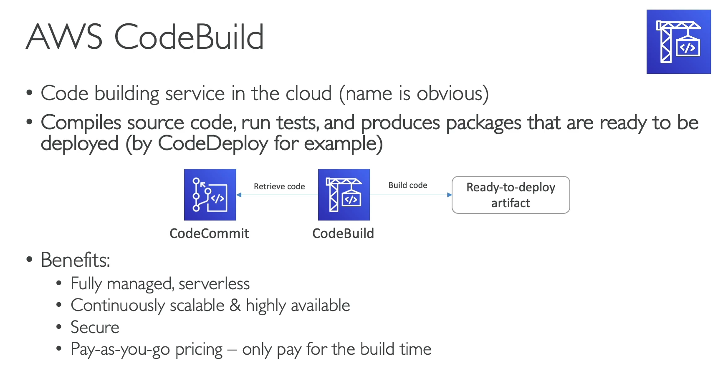

**AWS CodeBuild (Build Service)**

* **Purpose:** CodeBuild is a **fully managed build service** that compiles your source code, runs unit tests, and produces artifacts (packages) that are ready for deployment.
* **Functionality:** It automates the "build" phase of a continuous integration and continuous delivery (CI/CD) pipeline. It takes source code from a repository (like CodeCommit or GitHub) and executes a defined build process.
* **Key Benefits:**
  + **Fully Managed and Serverless:** You don't need to provision or manage any servers. CodeBuild runs your build tasks in a fully managed, serverless environment.
  + **Pay-as-You-Go:** You are only billed for the compute time that your builds consume, making it a cost-effective solution.
  + **Scalable and Highly Available:** CodeBuild can scale automatically to handle multiple concurrent builds, ensuring that your development pipeline is not a bottleneck.
  + **Integration with Developer Tools:** It integrates seamlessly with other AWS Developer Tools, such as **CodeCommit** (for source code) and **CodeDeploy** (for deployment).
* **Workflow:**
  1. **Source Code Retrieval:** CodeBuild retrieves source code from a specified repository.
  2. **Build Execution:** It runs a series of commands (defined in a build specification file) to compile the code, run tests, and perform other necessary build tasks.
  3. **Artifact Production:** The output of the build process is a "build artifact" (a ready-to-deploy package, such as a zipped application or a container image), which can then be used by other services like CodeDeploy.

1. **CodePipeline Overview:**

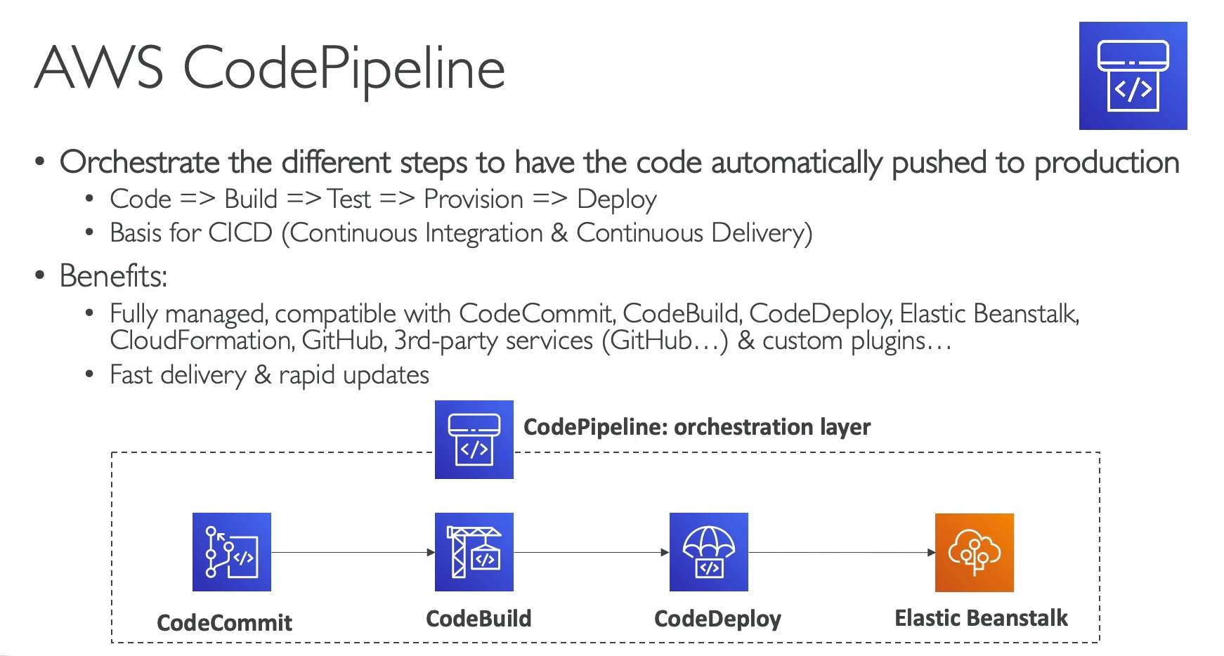

\**AWS CodePipeline (Orchestration Service)**

* **Purpose:** CodePipeline is a **fully managed continuous delivery service** that helps you automate the steps required to release your software. It acts as an orchestration layer, creating a "pipeline" of interconnected stages.
* **Core Functionality:**
  + **CI/CD Orchestration:** CodePipeline is the central tool for implementing a **Continuous Integration and Continuous Delivery (CI/CD)** workflow on AWS. It automates the entire process, from a developer committing code to the application being deployed to production.
  + **Stages and Actions:** A pipeline is composed of stages (e.g., "Source," "Build," "Test," "Deploy"), and each stage contains one or more actions. CodePipeline manages the flow of the application through these stages.
  + **Automatic Triggers:** The pipeline is automatically triggered by a change in the source code repository, ensuring that every code change goes through the defined process.
* **Key Benefits:**
  + **Fully Managed:** You don't need to worry about managing the underlying servers or infrastructure for the pipeline itself.
  + **Deep Integrations:** CodePipeline is designed to integrate seamlessly with other AWS services, particularly the **AWS Developer Tools**, such as:
    - **CodeCommit** (Source)
    - **CodeBuild** (Build & Test)
    - **CodeDeploy** (Deployment)
    - **Elastic Beanstalk** (Deployment Target)
    - **CloudFormation** (Infrastructure Provisioning)
  + **Third-Party Support:** It also supports integration with popular third-party tools like **GitHub**, Bitbucket, and custom plugins.
* **Exam Perspective:** When you see a question about **automating a multi-step release process** or **orchestrating a CI/CD pipeline** on AWS, the answer is most likely **CodePipeline**. It is the central service that ties together all the individual components of the software release process.

1. **CodeArtifact Overview:**

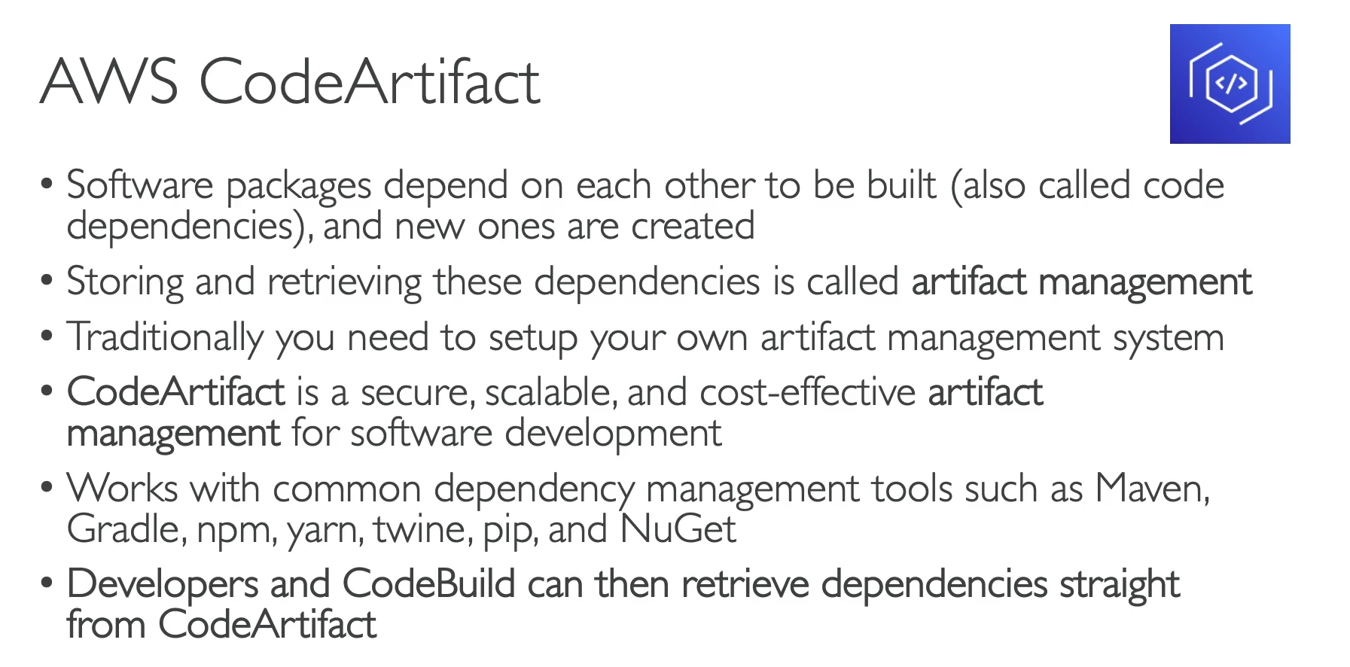

**AWS CodeArtifact (Artifact Management)**

* **Purpose:** CodeArtifact is a **fully managed artifact repository service**. It provides a centralized, secure, and scalable location for developers to store, publish, and share software packages and their dependencies.
* **Problem it Solves:** Before CodeArtifact, organizations had to set up and manage their own artifact management systems (e.g., on EC2 instances or S3 buckets), which could be complex and time-consuming. CodeArtifact removes this operational overhead.
* **Functionality:**
  + **Secure Storage:** It provides a default, secure place to store and retrieve code dependencies.
  + **Supports Common Tools:** It is compatible with a wide range of popular dependency management and build tools that developers already use, such as:
    - **Maven** and **Gradle** (for Java)
    - **npm** and **Yarn** (for Node.js)
    - **pip** and **twine** (for Python)
    - **NuGet** (for .NET)
* **Integration:**
  + CodeArtifact is designed to integrate seamlessly with other AWS Developer Tools.
  + For example, a **CodeBuild** project can automatically pull its required dependencies from a CodeArtifact repository, ensuring a consistent and secure build process.
* **Key Benefits:**
  + **Managed Service:** AWS handles the infrastructure, scaling, and maintenance.
  + **Cost-Effective:** It has a pay-as-you-go pricing model, so you only pay for the storage and requests you use.
  + **Security:** It provides secure and private repositories within your AWS account.
* **Exam Perspective:** CodeArtifact is the service to remember when a question on an exam asks about the need for a central, managed system to store and retrieve **software packages** or **code dependencies** for a development team.

1. **Systems Manager Overview:**

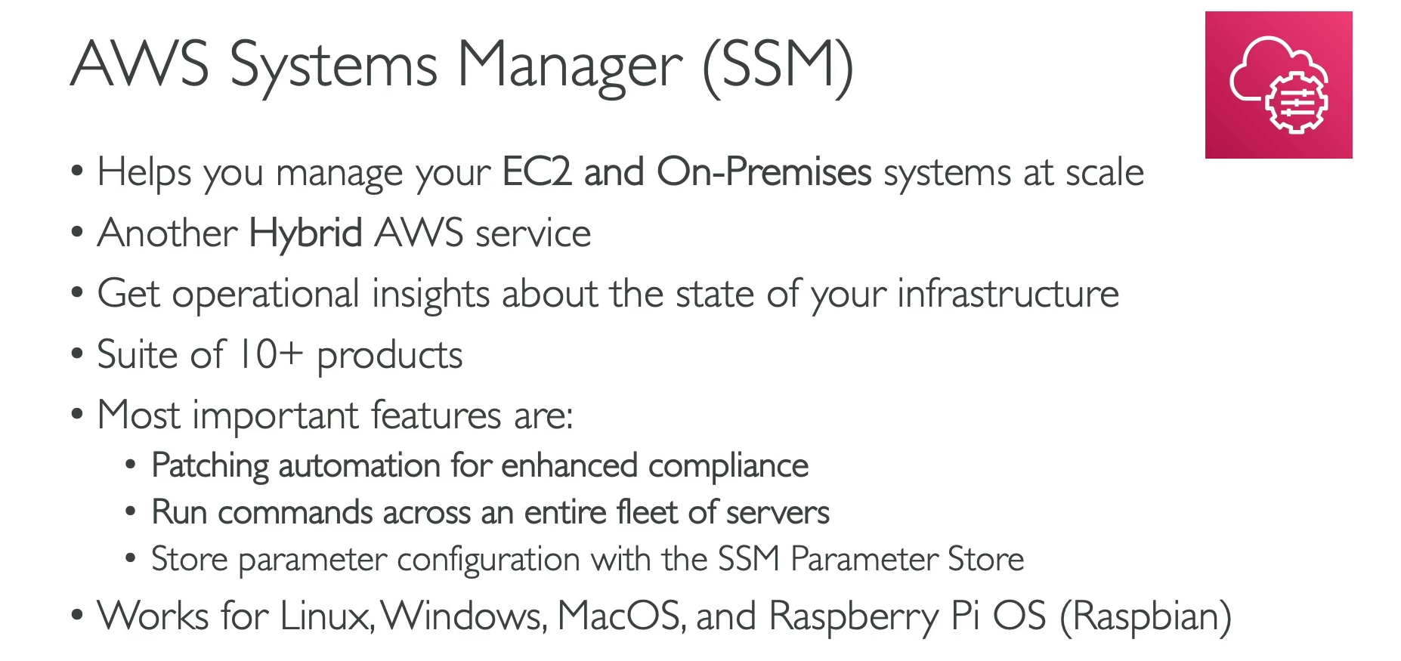

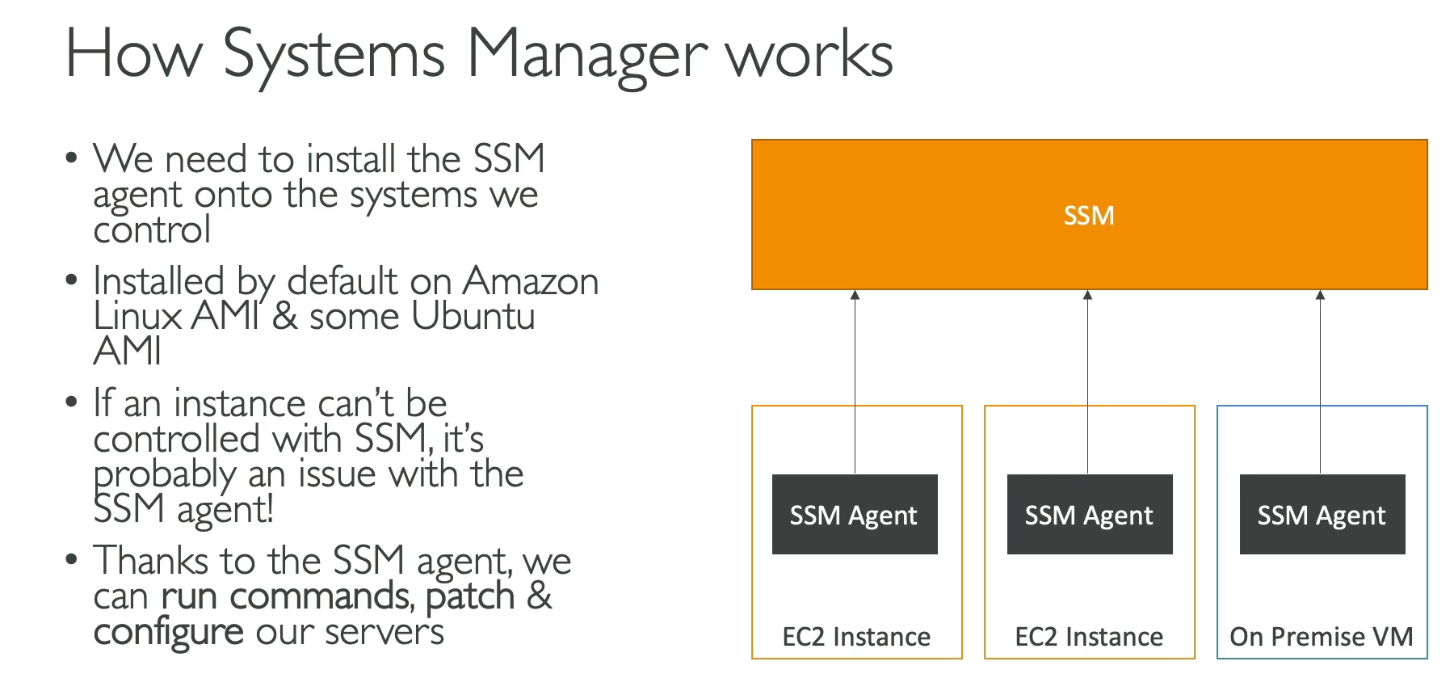

**AWS Systems Manager (SSM)**

* **Purpose:** Systems Manager is a management service that provides a unified interface for operational insights and management of your entire fleet of **EC2 instances and on-premises servers** at scale.
* **Hybrid Service:** A key feature of SSM is its status as a **hybrid service**. It can manage both your resources within AWS (EC2 instances) and your servers in an on-premises or multi-cloud environment.
* **How it Works:**
  + **SSM Agent:** To enable management, the **SSM Agent** must be installed on each server you want to control. This small piece of software runs in the background and reports back to the SSM service.
  + **Default Installation:** The SSM Agent is pre-installed on many official AWS AMIs (e.g., Amazon Linux, some Ubuntu versions). For on-premises servers or other operating systems, you must install the agent manually.
  + **Centralized Management:** Once the agent is installed and the systems are registered, you can use the SSM console to manage and monitor them from a single, centralized location.
* **Key Features and Benefits:**
  + **Automated Patching:** SSM's **Patch Manager** allows you to automate the process of patching and updating your servers to ensure they are compliant and secure.
  + **Run Command:** This feature allows you to securely execute commands, scripts, or management tasks across your entire fleet of servers from a central console, without needing to log in to each server individually.
  + **Parameter Store:** A component of SSM that provides a secure, hierarchical storage for configuration data and secrets, such as passwords, license codes, and database strings.
  + **Cross-Platform Support:** SSM agents are available for a wide range of operating systems, including **Linux, Windows, macOS, and Raspberry Pi**.

**Exam Perspective**

* **Core Concept:** Remember that SSM is the service for **centralized management of your servers**.
* **Key Use Cases:**
  + **Patching and Compliance:** If a question asks how to automate the patching of a large fleet of servers (EC2 or on-premises).
  + **Running Commands at Scale:** If a question asks how to run a consistent command or script across a large number of servers.
  + **Hybrid Management:** When a solution requires managing both cloud and on-premises resources from a single tool.

1. **SSM Session Manager:**

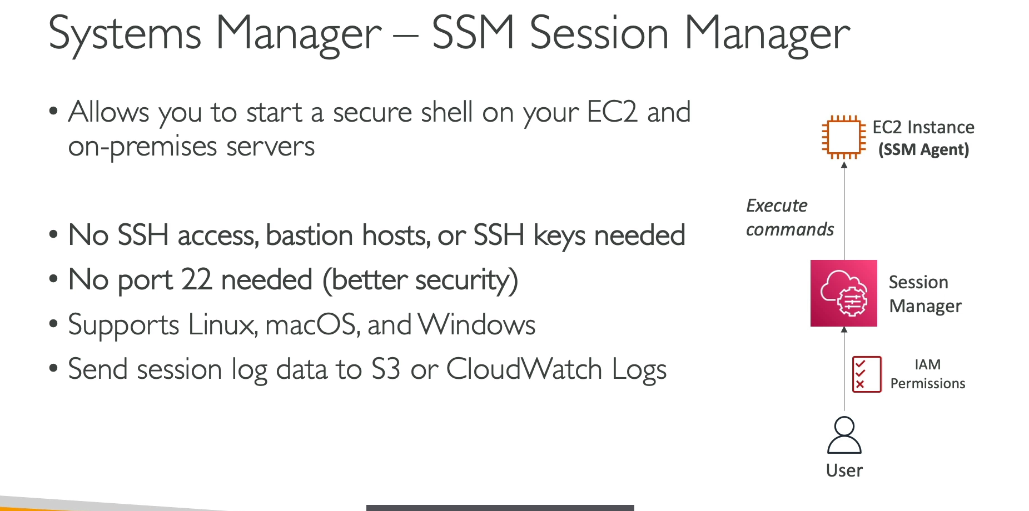

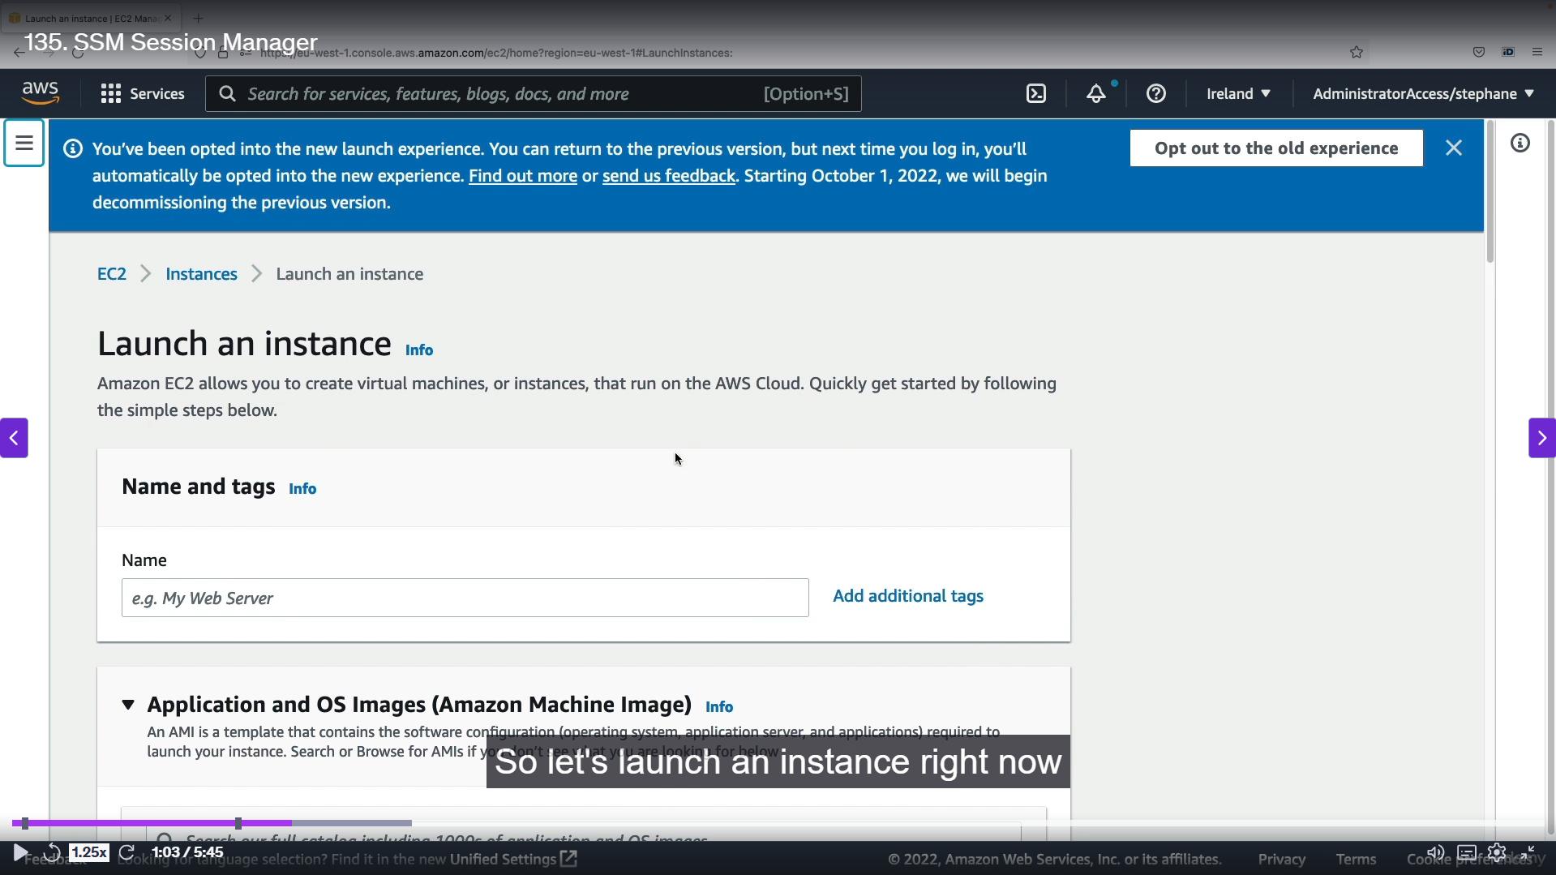

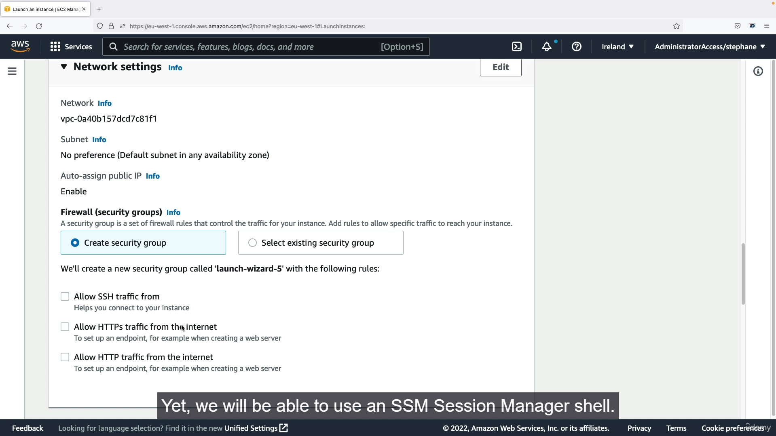

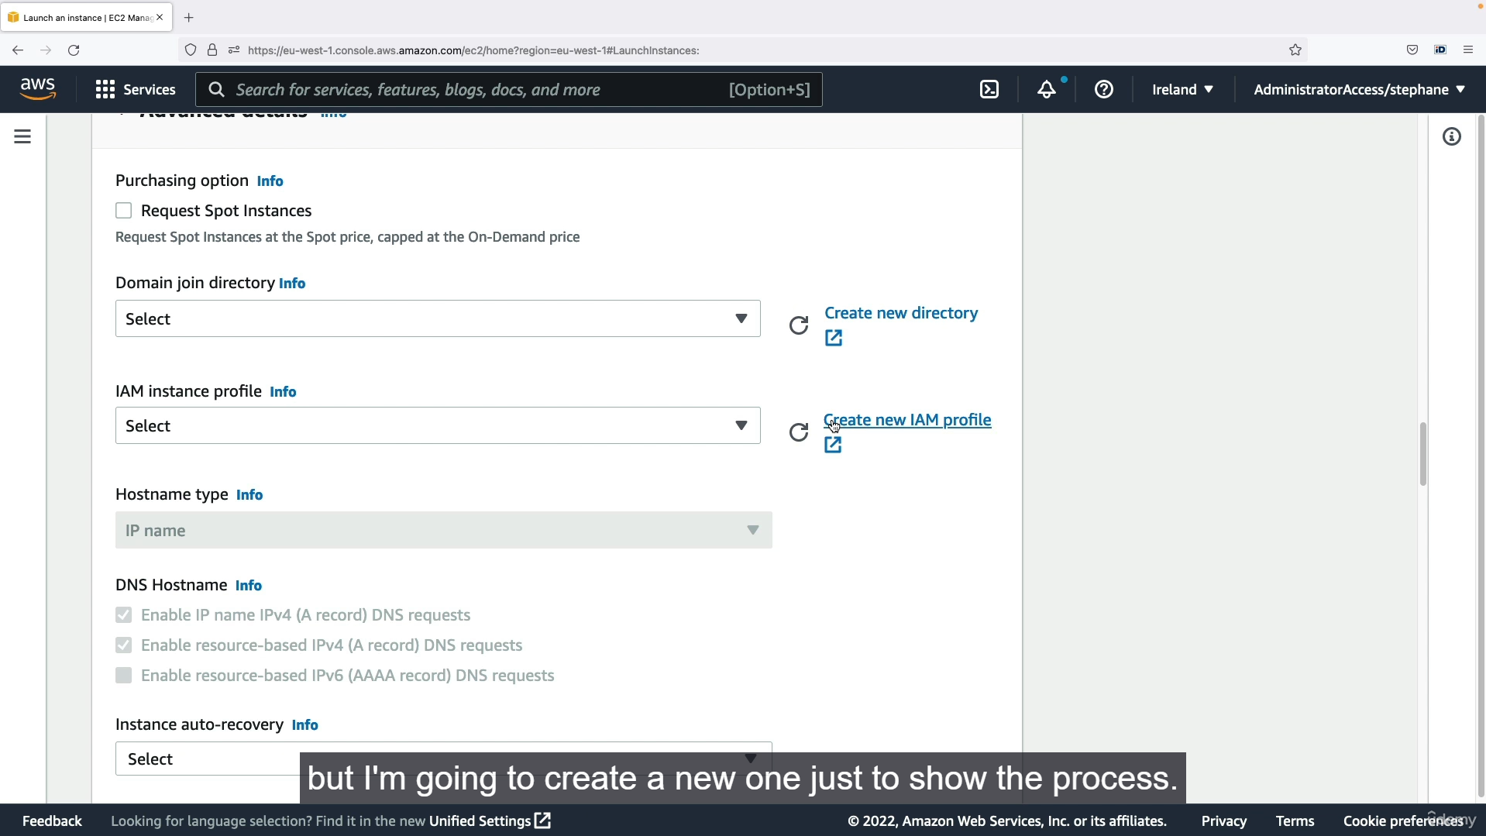

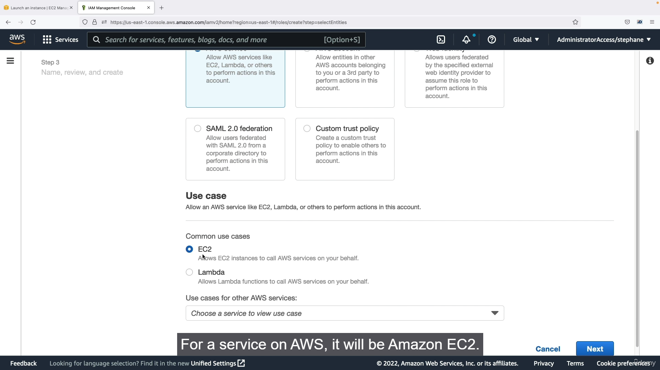

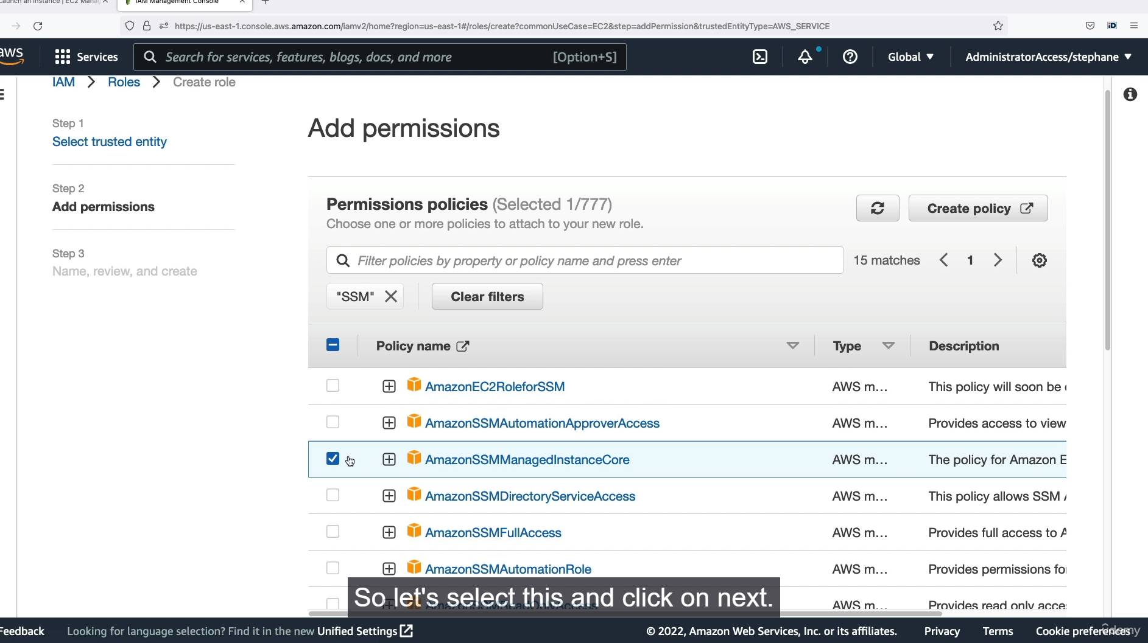

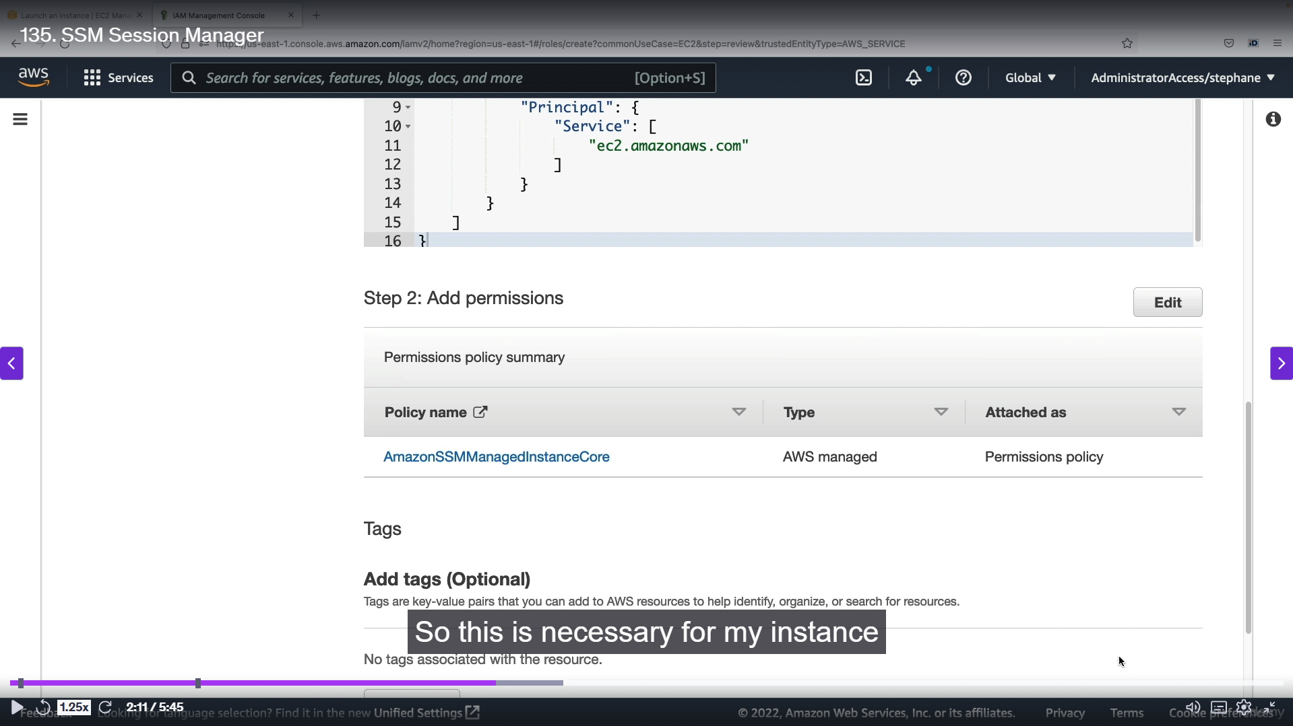

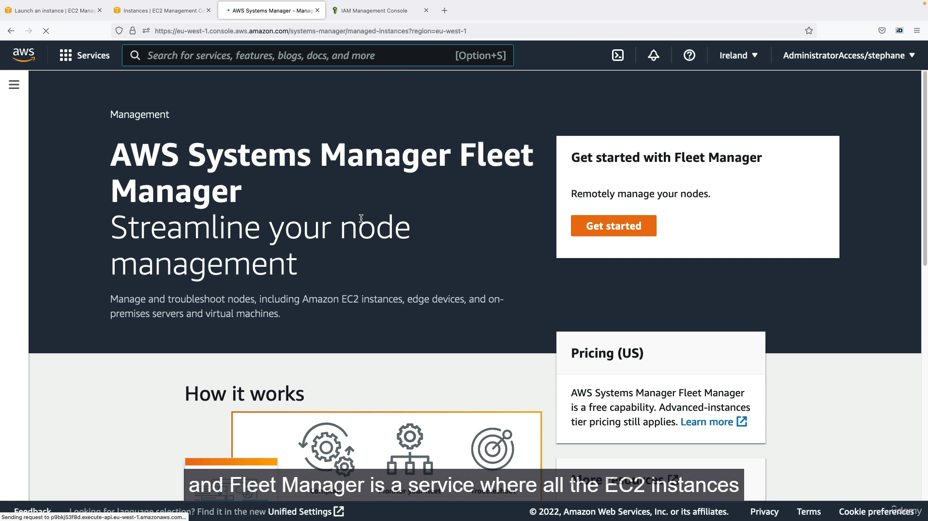

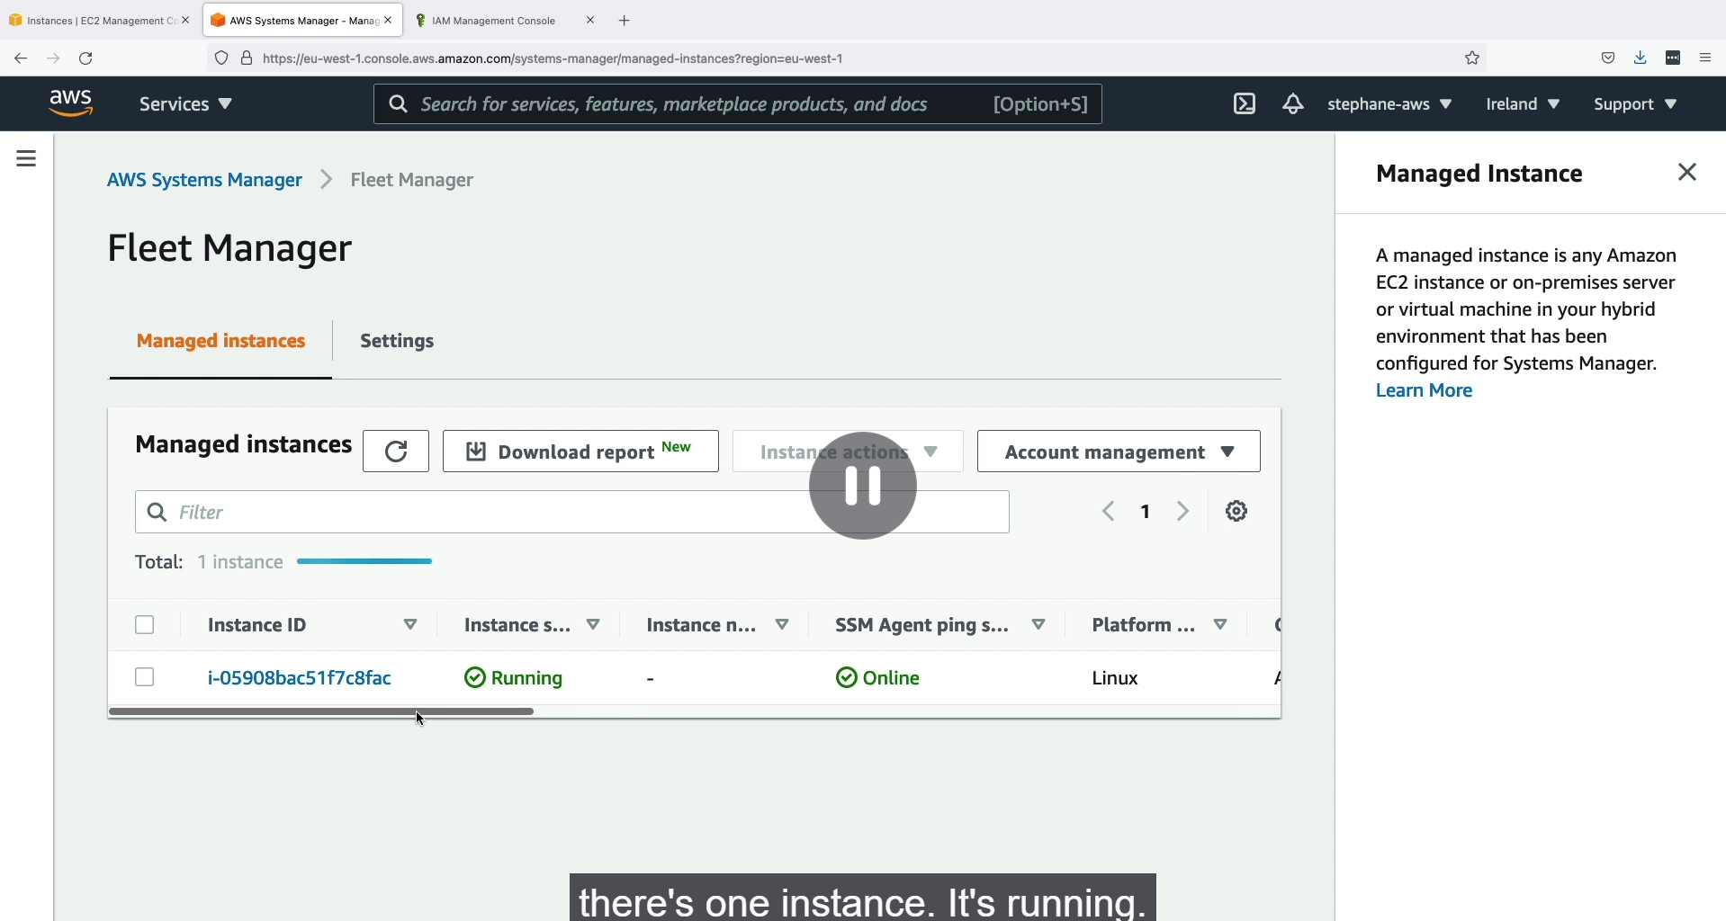

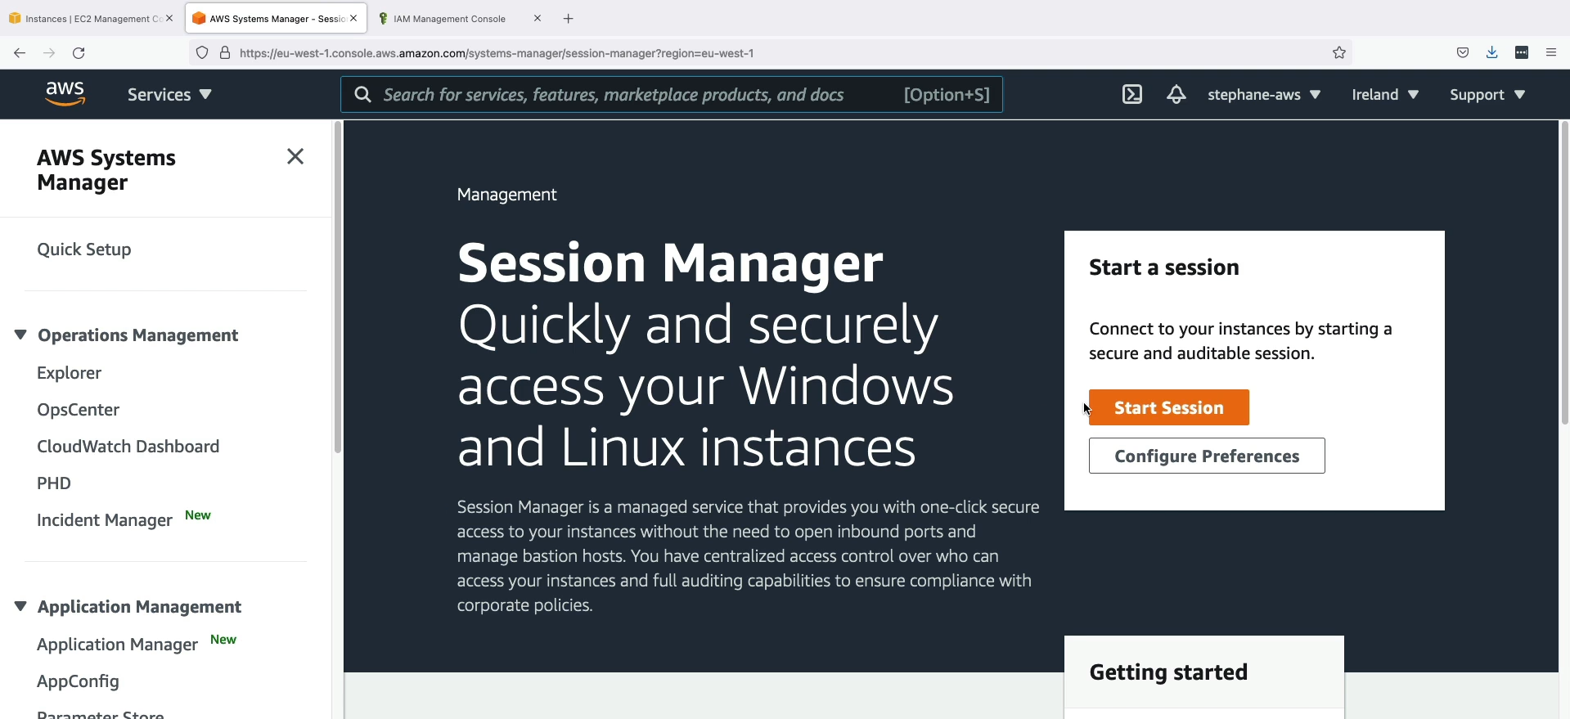

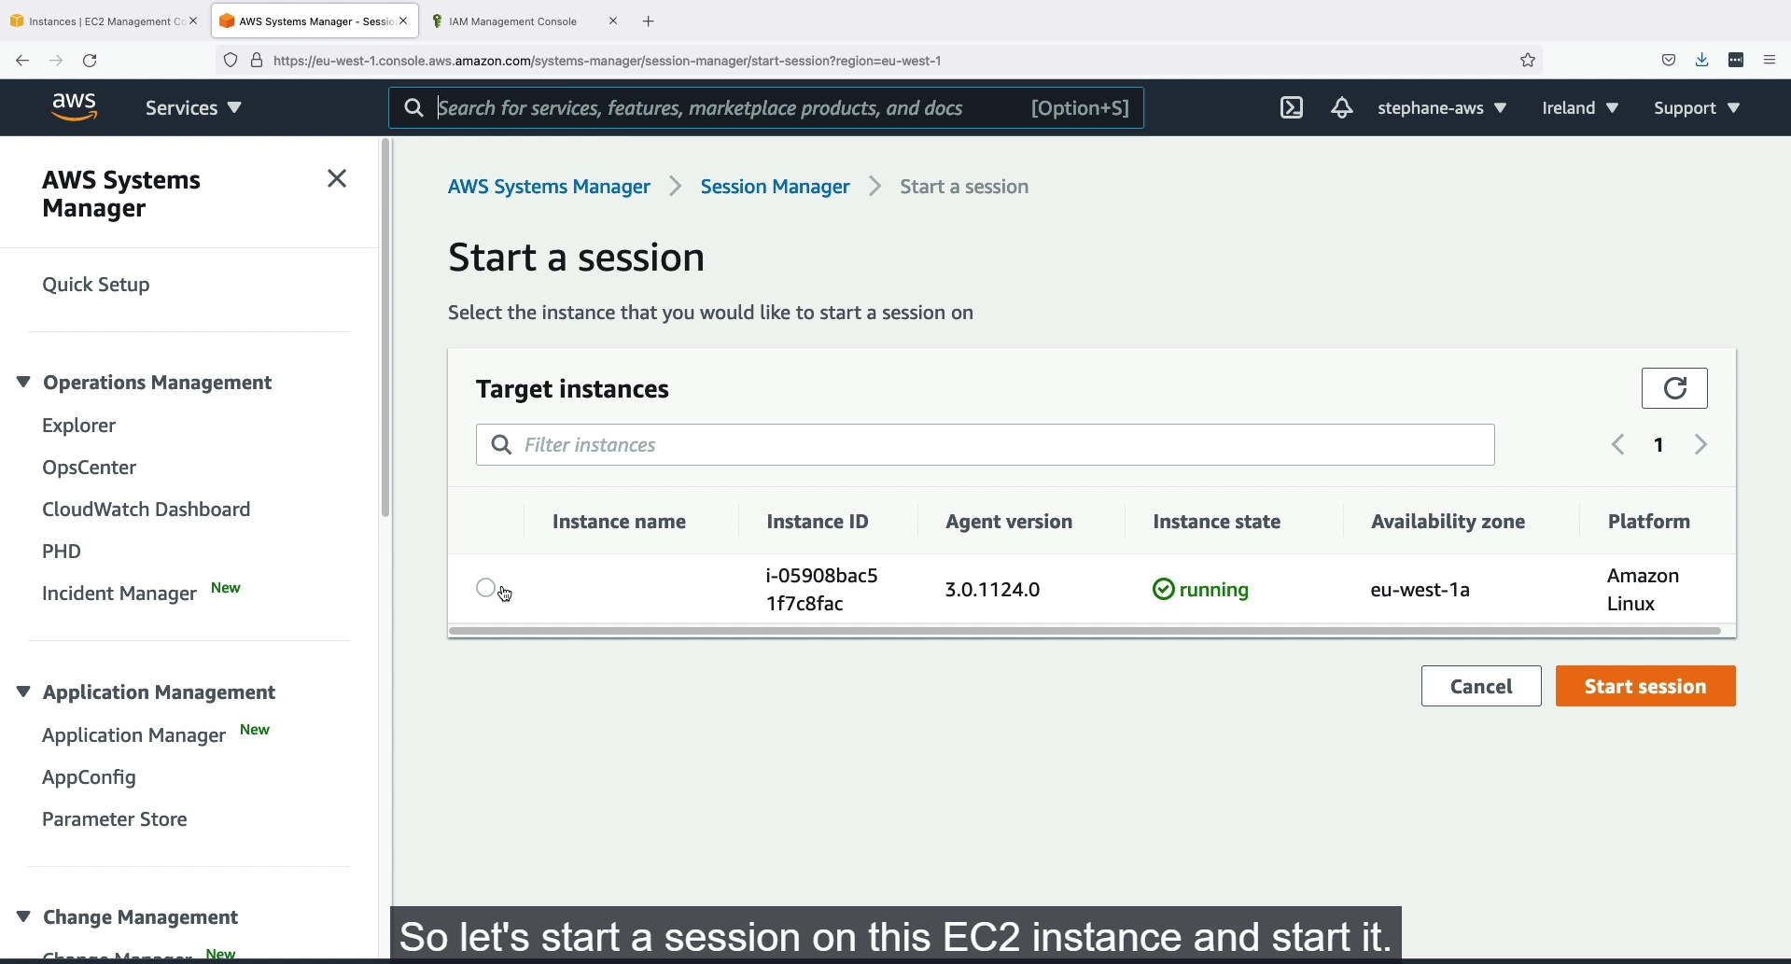

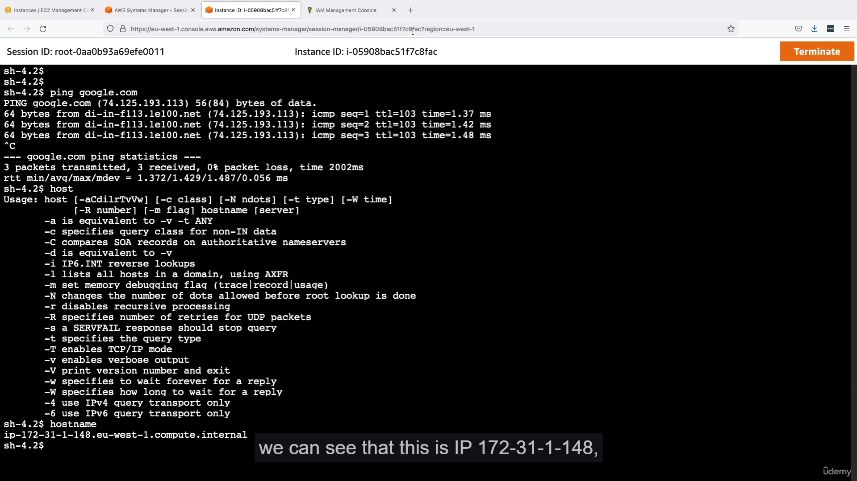

**SSM Session Manager**

* **Purpose:** Session Manager is a feature of AWS Systems Manager (SSM) that provides a secure, fully managed, and auditable way to access your EC2 instances and on-premises servers without the need for SSH keys, bastion hosts, or open inbound ports.
* **Enhanced Security:**
  + **No Open Ports:** It eliminates the need to open inbound ports like Port 22 (for SSH) in your security groups, significantly reducing the attack surface.
  + **No Keys to Manage:** Since it doesn't rely on SSH keys, you don't have the security risk of managing, distributing, or potentially losing keys.
* **How It Works:**
  1. **SSM Agent:** The target EC2 instance must have the **SSM Agent** installed and running. This agent is pre-installed on many official AWS AMIs.
  2. **IAM Role:** An **IAM instance profile** with a policy that allows communication with the SSM service (e.g., AmazonSSMManagedInstanceCore) must be attached to the EC2 instance. This grants the instance the necessary permissions to be managed by SSM.
  3. **Secure Communication:** The SSM Agent on the instance initiates a secure outbound connection to the SSM service endpoint. This "reverse connection" model is why no inbound ports need to be open on the instance.
  4. **User Access:** An AWS user with the correct IAM permissions can then start a session from the AWS console or CLI through the Session Manager service. The commands are relayed securely through the established connection to the agent on the instance.
* **Key Benefits:**
  + **Centralized Access Control:** Access is managed through IAM policies, allowing you to control who can access which instances and with what permissions.
  + **Auditable Sessions:** All session activity, including commands executed, can be logged to Amazon S3 or CloudWatch Logs for auditing and compliance purposes.
  + **Cross-Platform Support:** It supports Linux, macOS, and Windows operating systems.
  + **Ease of Use:** It provides a convenient, browser-based shell and is part of the larger Systems Manager suite for a unified management experience.

**Comparison to Other Access Methods**

The text highlights three ways to access an EC2 instance, with Session Manager being the most secure and modern approach:

1. **Traditional SSH:** Requires an open Port 22 in a security group and the management of SSH key pairs.
2. **EC2 Instance Connect:** A more secure alternative to traditional SSH that temporarily uploads a public key to an instance. However, it still requires Port 22 to be open.
3. **SSM Session Manager:** The most secure method, as it completely eliminates the need for any open inbound ports and SSH keys, relying instead on IAM and a secure outbound connection from the instance to the SSM service.
4. **SSM Parameter Store:**

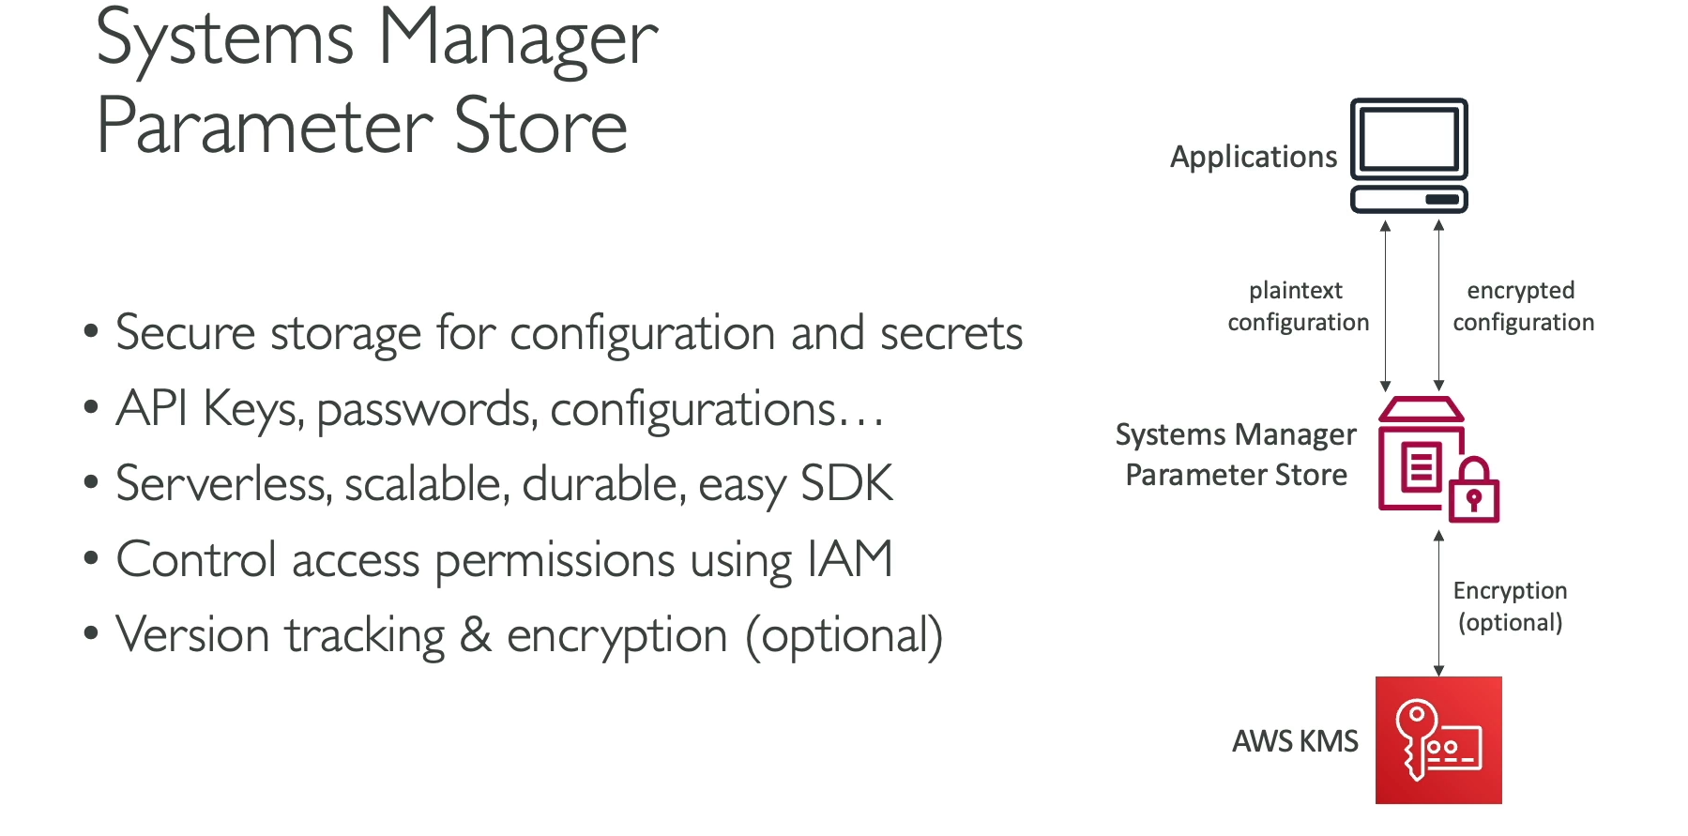

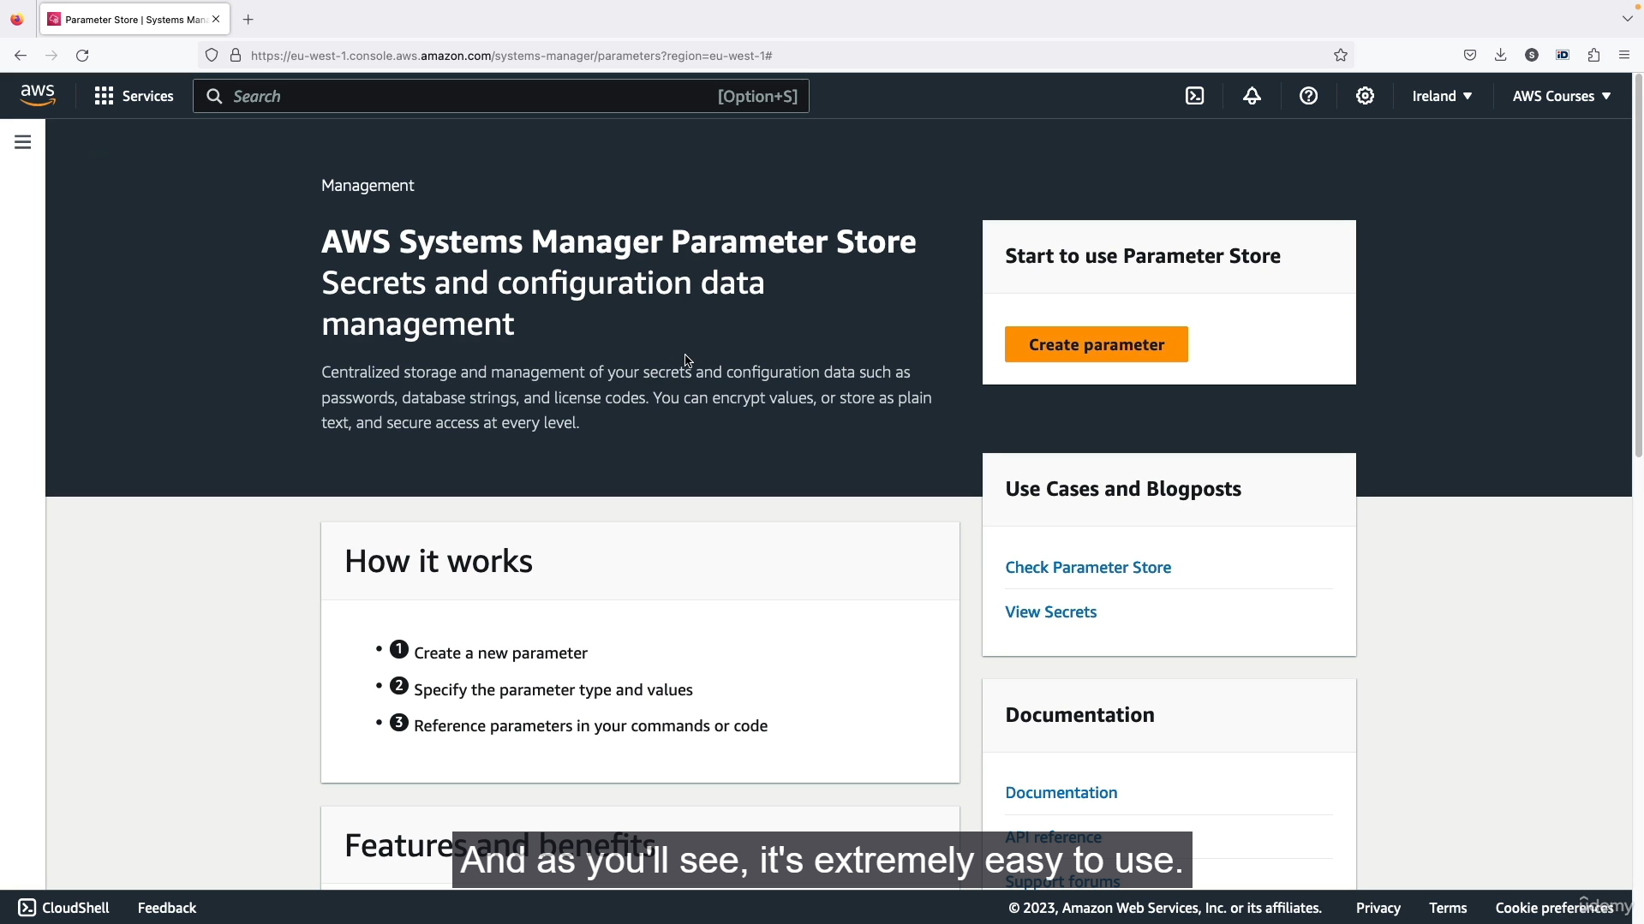

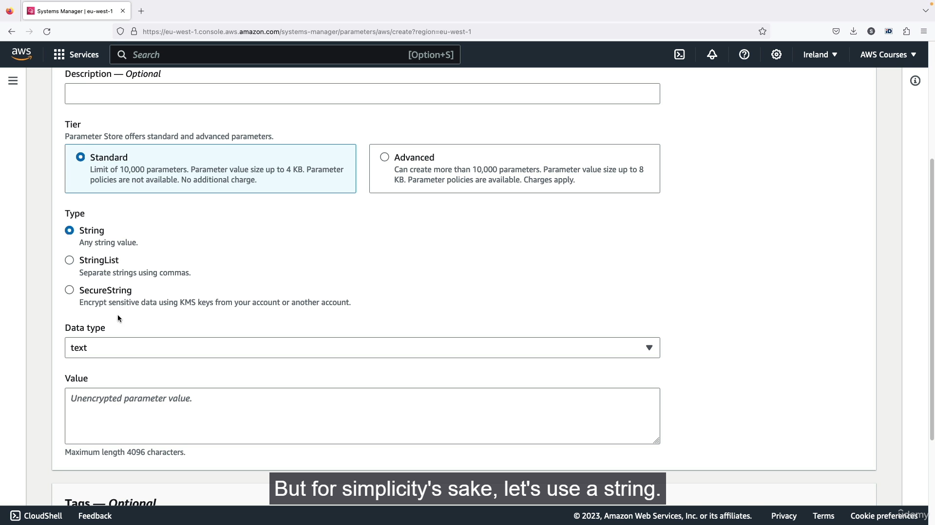

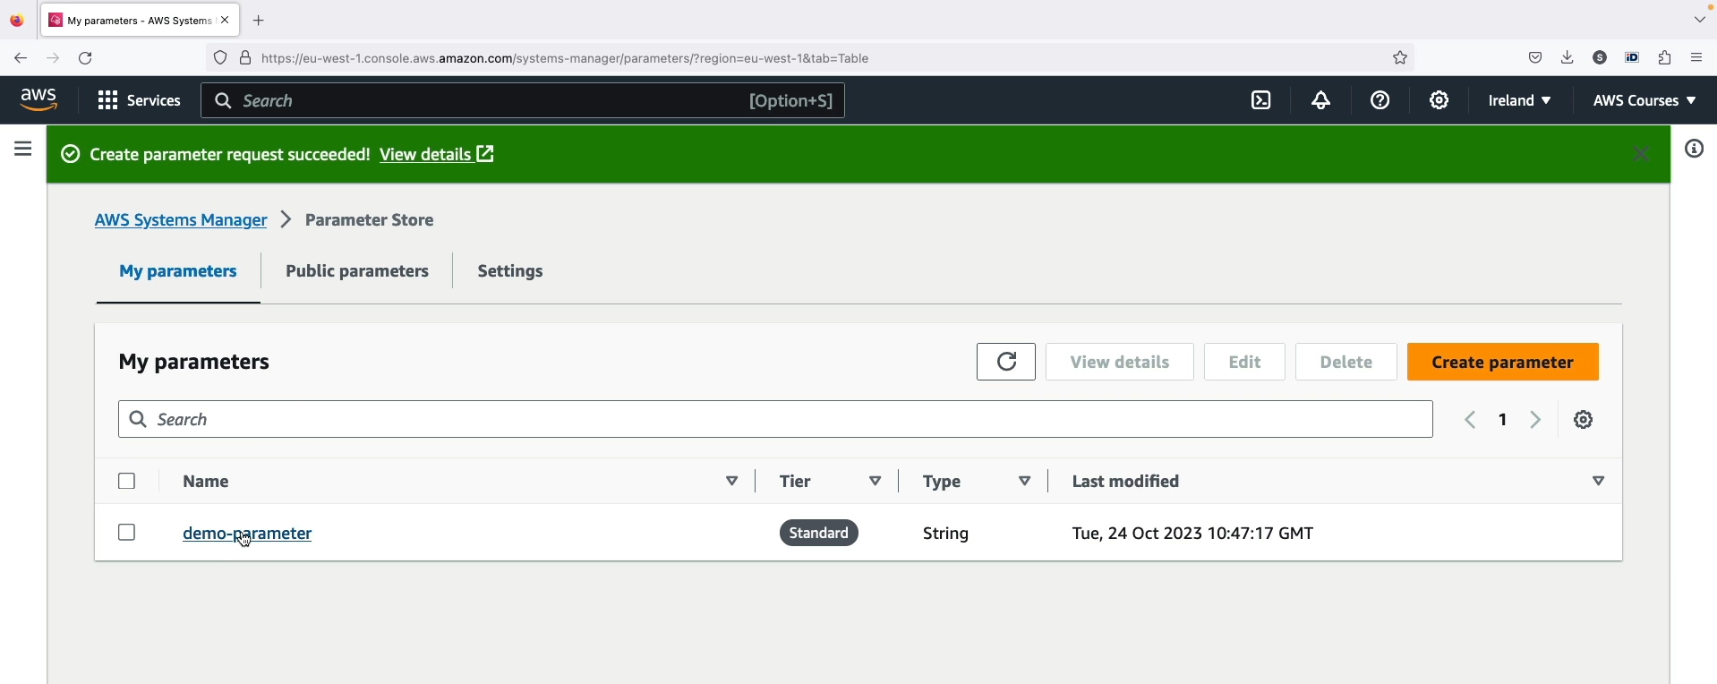

**Systems Manager Parameter Store**

* **Purpose:** The SSM Parameter Store is a feature of AWS Systems Manager that provides a **centralized, serverless, and secure** location to store configuration data and secrets. This eliminates the need to hardcode sensitive information (like API keys, passwords, and database connection strings) directly into your application code.
* **Key Features:**
  + **Serverless:** There is no infrastructure to provision or manage. The service is fully managed by AWS.
  + **Secure:** You can store secrets as **Secure Strings**, which are encrypted using AWS Key Management Service (KMS). Access to all parameters is controlled via **IAM policies**, ensuring only authorized users or services can retrieve them.
  + **Scalable and Durable:** The service is highly available, durable, and can handle a high volume of API requests, making it suitable for applications at any scale.
  + **Version Control:** Parameters are versioned, so you can track changes over time and easily roll back to previous values if needed.
  + **Hierarchical Structure:** You can organize parameters in a logical, hierarchical structure (e.g., /prod/app1/database_password) to make them easy to manage and control.
* **Parameter Types:**
  + **String:** For storing unencrypted configuration values (e.g., a simple URL or a non-sensitive setting).
  + **StringList:** For storing a list of values separated by commas.
  + **SecureString:** For storing sensitive data (e.g., passwords, API keys) that needs to be encrypted at rest.
* **Exam Perspective:** When an exam question mentions the need to **securely store and retrieve configuration data or secrets** for multiple applications in a central location, **SSM Parameter Store** is the correct service to think of. It is a fundamental component for building secure and well-architected applications on AWS.

1. **Deployment Summary:**



